**TASK-4**

Creating Virtual Machine, Snapshot and images

1. Created **Resource Group** with name **AnnuRG.**

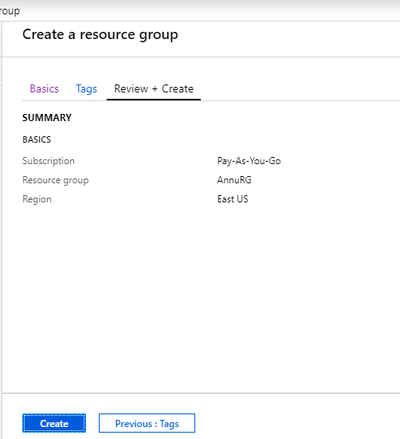

1. Created **Virtual Network** inside AnnuRG resource group with name **AnnuVnet** and **Subnet** with name **Frontend.**

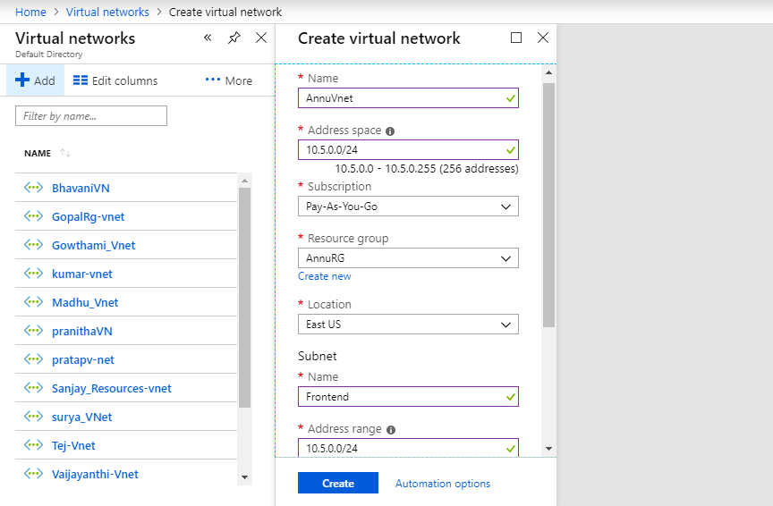

1. Created **Network Security Group** with name **AnnuNSG.**



1. Adding Inbound Security rule in AnnuNSG with name **Port_RDP**, **Port_SSH**, **Port_HTTP.**

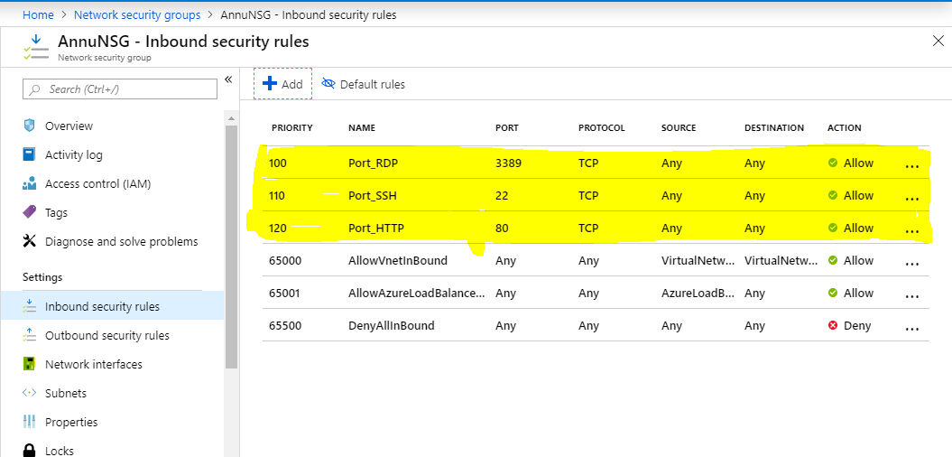

1. Associate Subnet to NSG

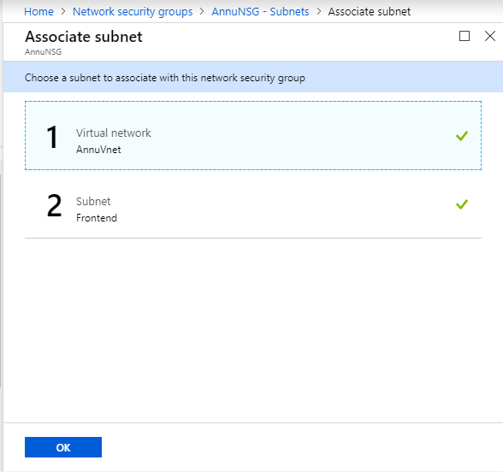

1. Created **Virtual machine** with name **AnnuVM.**

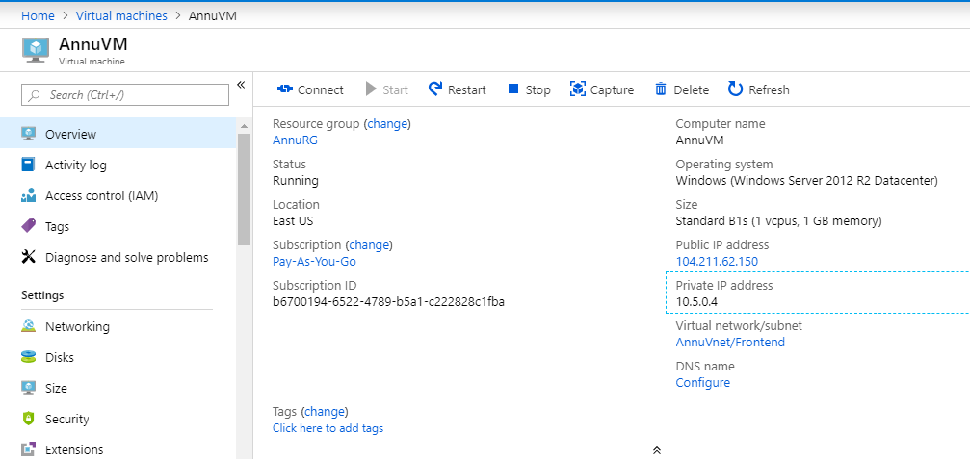

1. Created **Snapshot** with name **AnnuSnap** in **AnnuVM.**

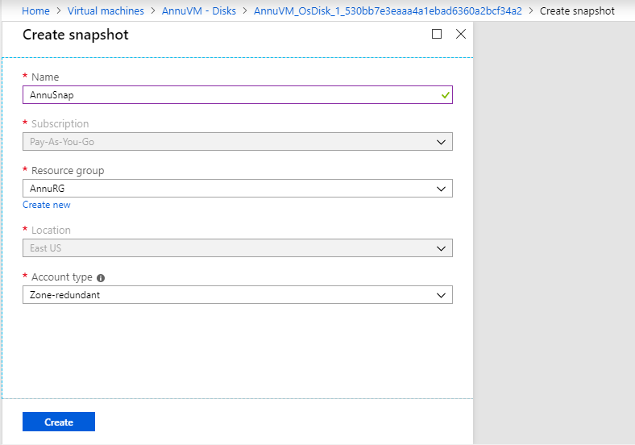

1. Created **Managed disk** with name **AnnuManageDisk.**

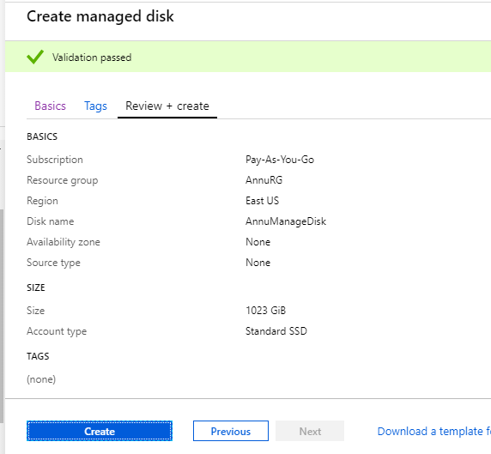

1. Created another virtual machine (**ANNUvm1**) with Snapshot.

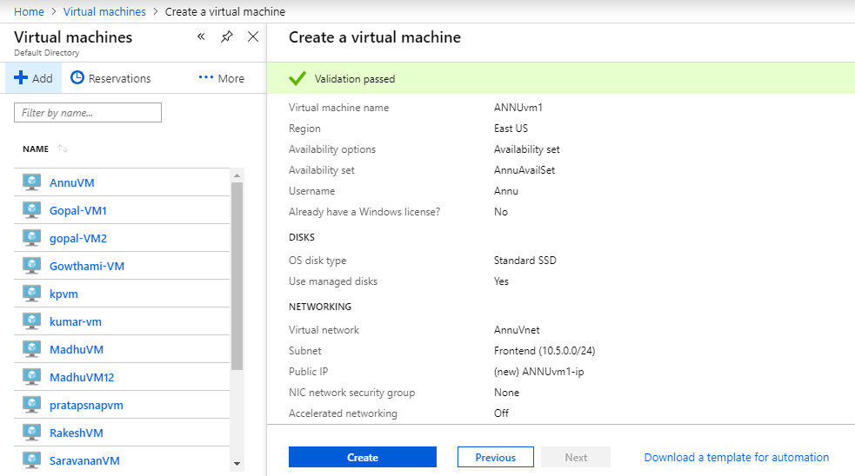

1. **Connect AnnuVM to RDP and SysPrep and shutdown.**

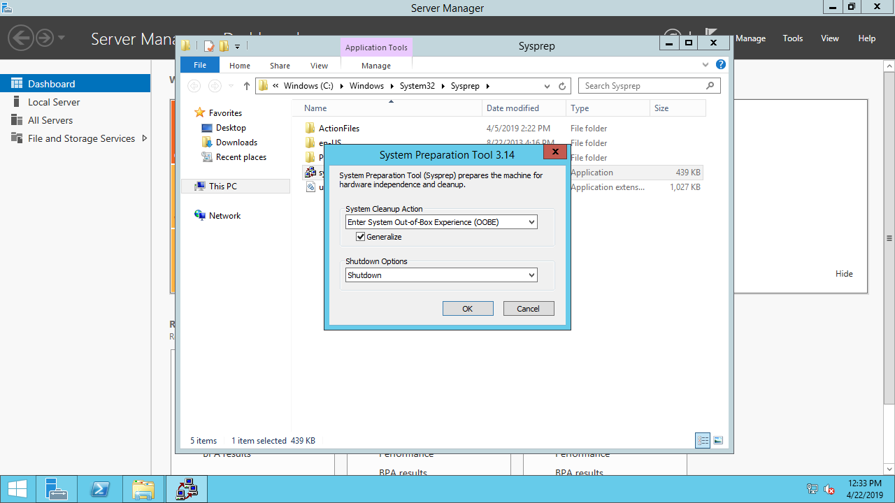

1. Create images

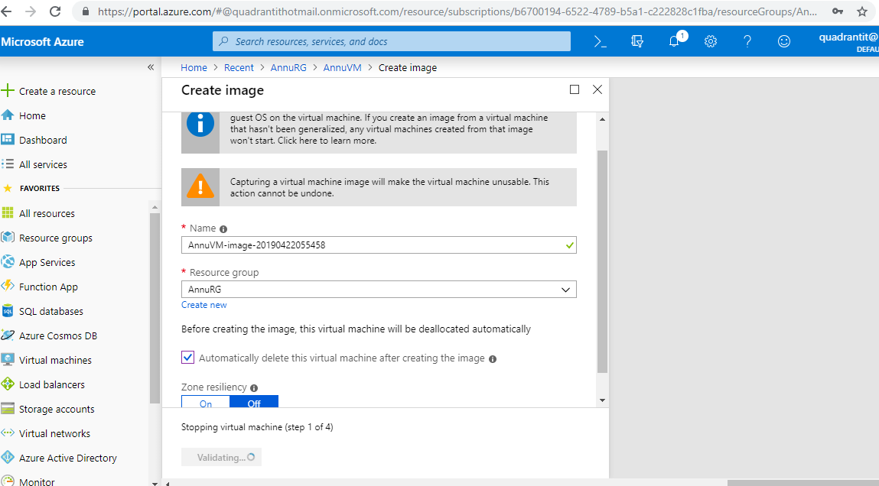

1. Created **Virtual Network** with name **ANNUvm2** with created images.

